**Title (Cambria, 12 points (pts.), bold, capitalize all the words, center justified)**

First name Last namea, First name Last nameb, …, First name Last namec,* (Cambria, 11 pts., * after the corresponding author)

*aAffiliation (Cambria, 10 pts., italicized, Center Alignment)*

*aFaculty of Interdisciplinary Studies, Khon Kaen University, Nong Khai Campus, Nong Khai, 43000, Thailand*

\**Corresponding Author’s E-mail: corresponding Author (Cambria, 10 pts., italicized, Center Alignment)*

**ABSTRACT**

(The text of the proceeding must be written using Cambria, 11 points, fully justified, line spacing = 1. The maximum length of the abstract is 200 words-300 words between 200 and 300 words. (Cambria, 11 pts., Justify alignment)

The murals of the Tang dynasty offer invaluable insights into the cultural information of that society by serving as critical cultural artifacts for understanding its social, historical, and cultural development.

xxxxxxxxxxxxxxxxxxxxxxxxxxxxxxxxxxxxxxxxxxxxxxxxxxxxxxxxxxxxxxxxxxxxxxxxxxxxxxxxxxxxxxxxxxxxxxxxxxxxxxxxxxxxxxxxxxxxxxxxxxxxxxxxxxxxxxxxxxxxxxxxxxxxxxxxxxxxxxxxxxxxxxxxxxxxxxxxxxxx

xxxxxxxxxxxxxxxxxxxxxxxxxxxxxxxxxxxxxxxxxxxxxxxxxxxxxxxxxxxxxxxxxxxxxxxxxxxxxxxxxxxxxxxxxxxxxxxxxxxxxxxxxxxxxxxxxxxxxxxxxxxxxxxxxxxxxxxxxxxxxxxxxxxxxxxxxxxxxxxxxxxxxxxxxxxxxxxxxxxx

By catering to the preferences and expectations of local and non-local visitors, the museum can enhance its information design and overall visitor experience, enriching the exploration of Tang dynasty murals and cultural history.

**Keywords:** Tang dynasty murals; museum information design; visitor experience; cultural heritage interpretation; exhibition design; visitor information needs (Cambria, 10 pt., Left Alignment)

(1.The full paper must not exceed 8 pages. ICGMS 2024 uses the APA style of citing and referencing.)

**1. INTRODUCTION**

One of the most recent concerns confronting the tourism industry has been ……………………………….. This can lead to the deterioration of cultural traditions and practices as they are modified to meet the tourists’ expectations and to generate revenue (Wang et al., 2017). As tourist places aim to appeal to a mass market by selling a standardized product, this can lead to the homogeneity of cultural experiences. Excessive tourism development will hasten the extinction of cultural heritage (Tian et al., 2020).

(leave a blank line after the section)

**2. MATERIALS AND METHODS**

**2.1 Research objectives**

**2.2 Research methodology**

**2.3 Research instruments**

(leave a blank line after the section)

**3. Findings and Discussion**

**3.1 Subsection 1**

As shown in Table 1,………..

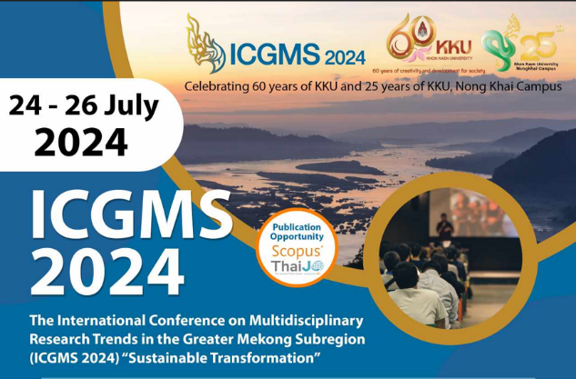

**Figure 1.** Figure shows The International Conference on Multidisciplinary Research Trends in the Greater Mekong Subregion 2024 poster.

**Table 2:** Tour Program Assessment Results (Cambria, 10 pts.)

|  |  |  |  |
| --- | --- | --- | --- |
|  | **Column 1 (Cambria, 8 pt., Bold, Center)** | **Column 2** | **Column 3** |
| **Sub-topic (Cambria, 8 pt., Bold, Align Left)** |  |  |  |
| **Row 2 (Cambria, 8 pt., Align Left)** | Detail (Cambria, 8 pt., Center) | Detail | Detail |
| **Row 3** | Detail | Detail | Detail |
| **Row 4** | Detail | Detail | Detail |
| **Sub-topic** |  |  |  |
| **Row 5** | Detail | Detail | Detail |
| **Row 6** | Detail | Detail | Detail |
| **Row 7** | Detail | Detail | Detail |

The International Conference on Multidisciplinary Research Trends in the Greater Mekong Subregion 2024 Figure

**Figure 2.** Example of a figureม the figure should be at the top or bottom of the page. (Cambria, 10 pts.)

**3.2 Subsection 2**

**3.3 Subsection 3**

(leave a blank line)

**4. CONCLUSION**

**4.1 Conclusion**

**4.2 Suggestions**

**ACKNOWLEDGEMENTS**

xxxxxxxxxxxxxxxxxxxxxxxxxxxxxx

(leave a blank line after the section)

**REFERENCES** (In APA style)

Article in a journal

Anantamongkolkul, C., & Pattanapokinsakul, K. (2022). Insights into cultural tourist behavior: A mixed-methods study. *Humanities, Arts and Social Sciences Studies*, 22(3), 523–535.

Charoensit, J., Emphandhu, D., & Phongkhieo, N. T. (2022). Travel motivations to visit CBT communities adjacent to national parks in the southern region of Thailand. *Humanities, Arts and Social Sciences Studies*, 22(1), 50–61. https://doi.org/10.1111/j.1944-9720.1991.tb00495.x

Herron, C. A., & Seay, I. (1991). The effect of authentic aural texts on student listening comprehension in the foreign language classroom. *Foreign Language Annals*, 24(6), 487–495. <https://doi.org/10.1111/j.1944-9720.1991.tb00495.x>

Hidayat, F. A., & Pandin, M. G. R. (2021). Pancasila Identity Among Millennial Generation in the Globalization Era. Preprints. https://doi.org/10.20944/preprints202106.0321.v1

Maiello, C., Oser, F., & Biedermann, H. (2003). Civic knowledge, civic skills and civic engagement. *European Educational Research Journal*, 2(3), 384–395. <https://doi.org/10.2304/eerj.2003.2.3.5>

Tsai, W. T., Chang, C. Y., Wang, S. Y., Chang, C. F., Chien, S. F., & Sun, H. F. (2001). Utilization of agricultural waste corn cob for the preparation of carbon adsorbent. *Journal of Environmental Science and Health - Part B Pesticides, Food Contaminants, and Agricultural Wastes*, 36(5), 677–686. https://doi.org/10.1081/PFC-100106194

Conference article/Proceedings

Laviosa, F. (1991, October 18–20). An investigation of the listening strategies of advanced learners of Italian as a second language [Paper presentation]. *The Conference on Bridging Theory and Practice in the Foreign Language Classroom*. Baltimore, MD, United States.

Game, A. (2001). Creative ways of being, In J. R. Morss, N. Stephenson & J. F. H. V. Rappards (Eds.), *TheoreticalIssues in Psychology: Proceedings of the International Society for Theoretical Psychology 1999 Conference* (pp. 3–12). Springer.

Book

Creswell, J. W. (2012). *Qualitative inquiry and research design: Choosing among five approaches* (3rd ed.). Sage.

Chapter in a book

Mulvey, L. (2006). Visual pleasure and narrative cinema. In M. G. Durham & D. M. Kellner (Eds.), *Media and cultural studies: KeyWorks* (pp. 342–352). Blackwell Publishing.